KINGS HILL WHEELERS CC

NEWSLETTER

DECEMBER 2023

INTRO

Welcome to the Christmas edition of the KHW CC newsletter, our second publication this year. In this edition, we have a review of the year, 2 reports from significant events by our members (well done to Sabrina and Sarah, and my thanks for penning 2 excellent reports), and some local club news about our sponsors, charities and social events.

As always, I will be pleased to receive any feedback you have on this newsletter, and any ideas or contributions to any future publications.

Finally, on behalf of the committee, we would like to wish you and your families a very merry Christmas and a happy and successful 2024.

CHAIRPERSON’S REPORT 2023

At the 2022 AGM, my predecessor, Mat McLoughlin, reported that 2022 had been a very good year for the club. I am delighted to be able to report the same for 2023.

It was always going to be a year of change. I was very privileged to be asked to take over from Mat as Chair, although he was always going to be a very tough act to follow. Also, there were 3 changes to the committee: Sabrina as Secretary; Rick as Events Manager; and Adrian as Welfare and Safety. This gave the team a good balance between experience and new blood. Having been Secretary on 2 previous occasions, I knew I had an excellent team to work with. My heartfelt thanks to everyone for making my job easy.

Our regular club rides have continued on a weekly basis much as in 2022. This is due in no small way to the unstinting work of Jon. Although the perception is that numbers are slightly down on previous years – which may be down to some inclement weather – we have still put out up to 6 rides each week.

A feature of our calendar has been the café stop rides once a month, when we have ridden to Rye, Whitstable and, of course, Folkestone. We plan to continue these rides next year and would welcome any suggestions for new routes.

Several of our members have participated in various events/sportives. These included the Kentish Killer, Ride London, the Spitfire ride, Chase the Sun, the Castle ride, the Tour of Cambridge, Hell of the Ashdown, the Outlaw triathlon, and the Yorkshire Trip. Every time someone participates in one of these events, whether it is a 30-mile sportive or 205 miles on Chase the Sun, they are representing the club and getting our name well known. Well done to you all.

We have again dabbled with the idea of setting up an off-road group, which has generated a small amount of interest. We will continue to monitor this, and maybe run an MBT ride once a month during the winter. Please let Jon know if this is something that would interest you.

On the financial front, the club is in rude health, thanks to some sound financial management by Clare. Key figures are as follows:

Income for 23/24 £3680
Current expenditure £751
Estimated outstanding payments £500-1000
Estimated profit £2,500 (approx)
Bank balance £6000 (approx)*

*This is before any charitable donations.

Our membership currently stands at 83, which is slightly down on the 92 we had last year. (There are currently 12 guest riders.) I believe this is a comfortable number for a club of our size and a long way from the 14 we had when the club formed 7 years ago.

Our website has been very efficiently run by Neil (together with his duties as Membership Secretary), who has reported that, for September (as a monthly example) we had 215 visits, 75% being from new visitors and 25% returning. We believe that our search engine strategy is working very well.

Rick took over as Events manager this year, which was his second stint on the committee, and oversaw a full programme. This included trips to the Velodrome, Mereworth wineries, and a few sessions in the Malling Jug. This year, we have decided a have a proper annual dinner at Kings Hill Golf Club in place of the Christmas carvery at the North Pole pub. This will be on 3 February, and I hope that many members and families will be able to attend. I believe that our events calendar makes us slightly unique as a club and contributes massively to our value of being a friendly club. If you have any ideas about future events, please let Rick know.

In my first year as Chairperson, I decided that a good outcome would be to try to maintain the very high standards set by Mat. At committee, we often discuss how we can grow the club, or even if we need to. Personally, I would like to see the membership at about 100 but probably no more. However, our major task this year, which has been confirmed by the majority of members who completed the club assessment, is how we get a greater turnout on all of our rides. As with everything else, I will be pleased to receive any feedback or suggestions.

I am delighted to say, and very relieved, that everyone on the committee has stood again for 2024, and I will be honoured to be Chairperson for a further year.

Jerry

Chase The Sun: South 2023

Saturday, my alarm pinged off at 2 am, and my loving husband woke with me to make the 40-minute drive to the start line. My cycle club buddies assembled at 4 am for a group picture as planned. I took the opportunity to tell them that I planned to ride solo. I was the only girl in the group; I was no match for their cycle abilities. We made our way to the start line and chatted while we watched the sunrise.

Amazingly, there was a large group of people having a swim at 4am! It was a true summer’s day. If England experiences 2 days of summer a year, this was one of them. It was forecast to be a hot one.

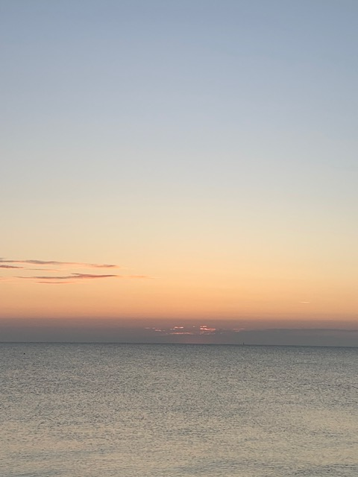
So, at the official sunrise, groups of 30 cyclists set off with 30 second gaps. Everyone was quiet as we cycled through the sleepy villages for the next few miles. That said, some locals chose to come out and wave us on. We had a steady start. I remained with the group for the first 20 miles. When the boys stopped for their first comfort break, I kept going. About 35 miles in, they had their second comfort break and still overtook me. Of course, I let them go. However, two guys, Mat and Pete, were still in sight. Mat asked, “How good are you at drafting?” With that, he rode away. If I was going to complete this ride, I needed to ride cleverly. I latched onto a wheel.

40 miles in, Mat said that he needed to stop to adjust his saddle. He requested that Pete and I, the last of the group, to carry on. I decided to have a comfort break while my friend sorted his saddle. I sought out privacy in a wooded area on the other side of the road. Afterwards, we had made an easy decision to stick together. At every intersection of the busy roads of London, we always looked amongst the other cyclists to find each other. We regrouped after each lump, bump, and hill. Whenever my speed lagged and the two disappeared ahead, they would take notice, drop back and drag me on with them. We were a small team.
With the Kent countryside behind us, I had witnessed one cyclist go down at the bottom of a hill due to a sharp bend and gravel. I was fully aware of poor road surfaces and the dangers it poses but this was a reminder. Keep pedalling but be careful!
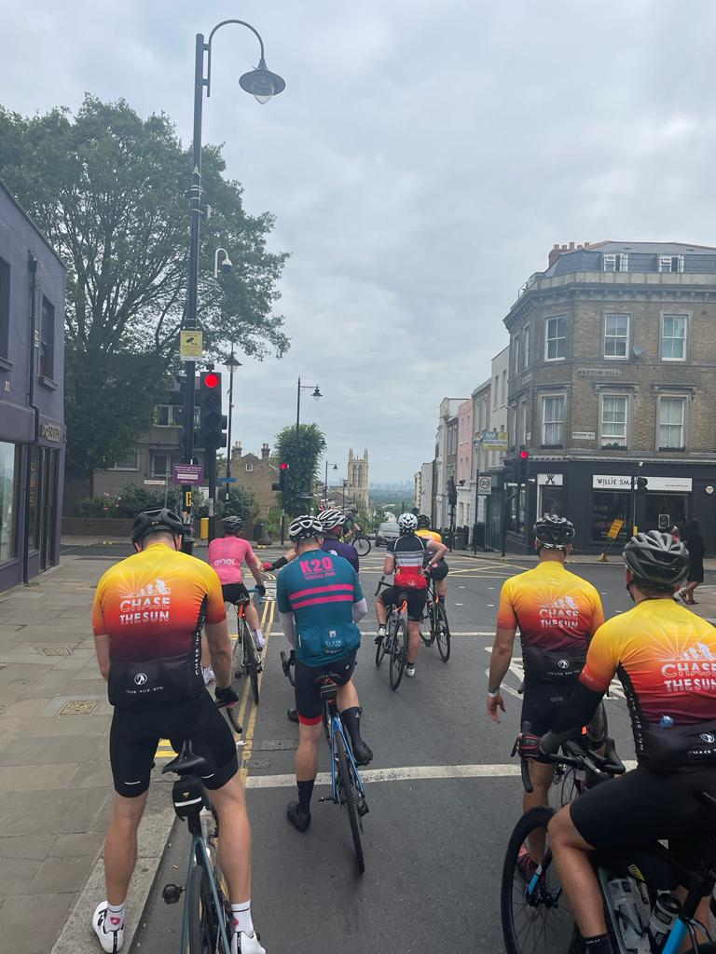
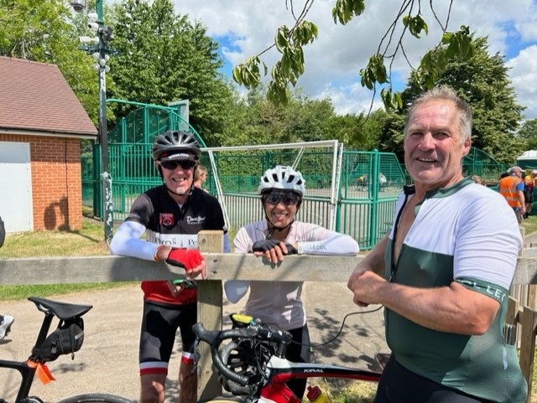
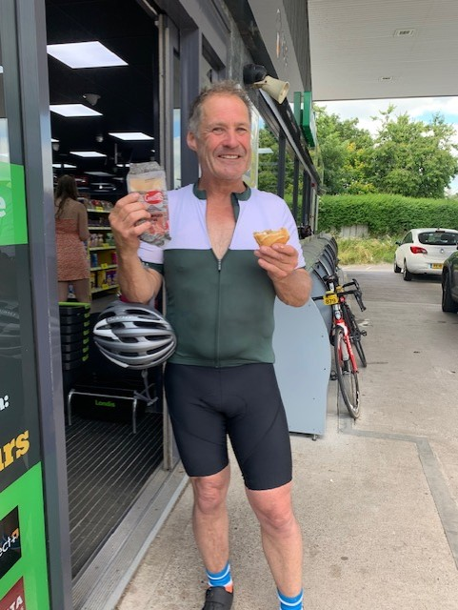
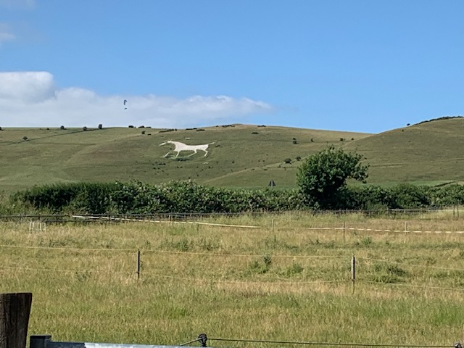
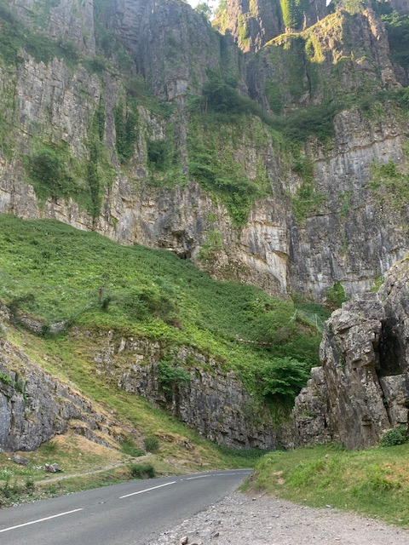
We climbed upwards to Crystal Palace, one of London’s highest points. This would be our breakfast stop and an opportunity to take in the views. We were a quarter way in. We all opted not to have coffee, but Pete and Mat refused my turmeric and matcha latte substitutes. They said that today was not the time to try new foods. It was a valid point.
The next 50 miles took us to midday, and temperatures were rising. The heat was sapping our energy. I suggested a fuel stop at 80 miles in. After a jovial fight over who paid for food, we happily ate sandwiches, crisps, and refilled water bottles. I reapplied my chamois cream – in the privacy of a toilet to be clear - not like some who chose to do this application by the side of a road. The stories you hear. As a first-time user, it was working a treat. We sailed into the 100-mile stopping point and registered. Hubby was there to check in and offer food, support, and a cuddle. I needed it.
Mat queued for the porter loos and came back feeling lighter. Pete’s feet were swelling in the rising heat, and he took the chance to remove his shoes for a short while. I gave Mat and Pete permission to leave me behind. I did not want to keep them back. They refused. Pete said, “We are gentlemen. Also, it is better to stay together in case of mechanicals.” He made his point. I was grateful. It was time to return to the saddle with my ‘ride or die’ friends.
We entered the next quartile of the ride, taking on narrow country lanes. Gravelly roads and undulations made it slow going. Fifteen miles after our lunch stop, we needed to stop.
Pete was melting! He was hot and bothered. His feet ached, he was low on water, and he didn’t feel like eating. His energy was low. Mat poured water from his water bottle onto Pete’s head to cool him down. We needed to replenish our fuel, but we were out in the sticks.
There were no petrol stations, cafes, or pubs around for miles. We needed to push on. Ten miles later, 125ish miles, we spotted a pub! Hoorah! We were greeted at the entrance by a member of staff to be informed that we could not enter or purchase food as they were hosting a function. Our available options were water, soft drinks, and crisps. So, we had to make do. This will have to be another interim stop offering short-term rewards.
Just enough to tide us over to a petrol station. Pete was crawling. Every increase in the road’s gradient knocked our friend back. They say there will be low points. This was his.
The proverbial watering hole presented itself at a petrol station 5 miles on. The air-conditioned shop was medicinal for Pete. He reached for a banana milkshake with a huge smile. He drank and ate happily. Mat and I were comforted that our teammate restored his battery stores. He was refreshed.
I armed myself with sandwiches stuffed into my cargo pockets, and I wanted to make a move. The last 30 miles were slow. We had lost a lot of time.
We started to tick the miles off. We travelled along the country roads, which reminded us of the beauty of the English countryside. We drafted on the wheels of other cyclists and allowed them to set the pace. Then we would overtake, making good speed.
I cannot tell you what speeds we travelled at, to be honest. The advice given was to keep the Garmin computer on the directions page. Do not look at numbers, miles, speed, time, etc. This would explain why I was unprepared for Mat to say, “Sabrina, we are both entering the unknown.” We must have been approaching 150 miles!
How do you eat an elephant? One bite at a time.
While I perform better than most up the hills, Mat and Pete can push more incredible watts on the flats. They were increasing the speed. I didn’t need the Garmin computer to prove it. I was under pressure to keep up.
I noticed a small crowd on the side of the road. As we cycled by, I saw a man with a bleeding head being attended to by paramedics. It was a cyclist. His ride was over. I was thankful at that point that my ride thus far was incident free. I still had my chance to finish.
My heart went out to him. We rode on. While stops are necessary for endurance rides, they do me no favours. Every time we stopped; my stomach cramped. I felt bloated, and I wretched up the tiny caffeine chew. My tummy had had enough. This was the unknown. At mile 176, my mates were stopping. I was thinking, not again. I hung my head over my handlebars.
They encouraged me to eat and drink. I ventured to have a Coke for its ability to settle tummies while pumping my system with sugar. Not a fuel snack I was accustomed to, but this was now the final push. Mat was offering fruit scones. I took one bite and put the rest away.
I consulted the official sticker sheet. We had two significant climbs to come, and there was Gorge with a smiley face. The temperatures were cooling. It was approximately 7:30, we had 30 miles to the end, and the Sun would set circa 9:30pm
To put a fine point on it. It takes an average of 2hrs to ride 30 miles. We were chasing the Sun! The boys sped up, and I held on. I knew I could do this. We passed others with ease. We went by a cyclist pushing his bike uphill, and yet the more prominent hills were still to come. We offered encouragement and forged ahead.
I grew quietly confident seeing others suffer. It was proving that I was a strong cyclist. I started to recognize my strengths that I had failed to acknowledge before. I got off my saddle and rode over the next few hills without pain.
I envisioned this ride months ago. I imagined crawling with no strength in my legs at mile 96 or 156. Either way, I thought it was going to be a painful experience.
Mile 190 manifested a completely different reality. I had 15 miles to go to the end. I welled up three times in the last few miles. Cycling downhill through the Cheddar Gorge filled me with delight. I felt euphoric.
I saw the beauty in my surroundings and started to process what I was achieving that day. I got this far with the help of my small community. My friends dared me to take on the Challenge. The same ones help me train and offer valuable advice. Especially with my nutrition.
The hubby who didn’t guilt me about money spent on power banks, new tyres, mechanics, hotel accommodation, and the list go on. He lost sleep and dedicated the day driving the route to be there for me on the other side. The kindness of strangers who made my last-minute repairs.
I remembered my daughter going out in stormy weather. It is much easier to achieve great things with a good support system. If it is one thing that this experience has shown me, I have a great one. I am so very grateful for that.
I cycled the last 15 miles with a grateful heart. We followed signs, as no one was in front to follow. Daylight was dipping. We took a left onto the pier—the marked finish line. Pete and Mat moved to the sides and gestured for me to cycle into the middle. Side by side, we cycled together towards the sunset. We made it!
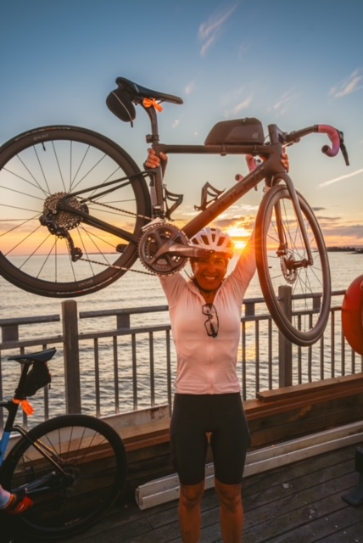
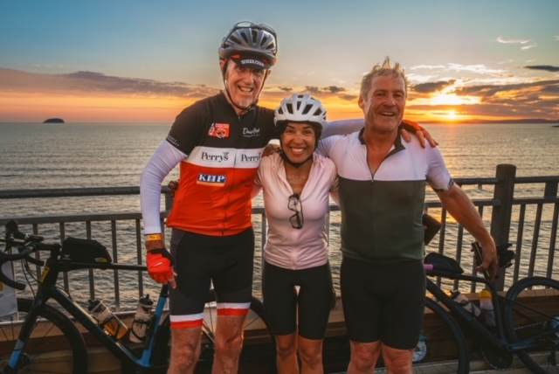
As CTS is not a race but a ride at the end there is no medal. Instead, there is a photographer there to help you capture beautiful sunset photos. Photos that you can look at fondly to remind you of what you had achieved that day.

Sabrina
THE OUTLAW TRIATHLON

Sunday was The Outlaw up in Nottingham. Where do I start? Well, I had wanted to do this last year for my 50th but shoulder surgery put paid to any hope of the training required, so I signed up to do it this year aged 51. The countdown went from its next year to months away, then to weeks, then days and hours, finally the day arrived. A 2.45am alarm call and, before I knew it, I was in the lake with the announcement of ‘2 1/2 minutes’ to go. 6am, off I went - the swim course looked the biggest loop I’d ever seen in my life. Pretty darn choppy in there due to the wind and after the 2nd turn buoy it felt so, so long. I started off in the mix of the washing machine and went in search of friendly feet from the get-go - swimming unilaterally as I took a few knocks and then settled into my bilateral breathing and found my rhythm. I’d had times over the past couple of months where I had been really down on myself over my open water swim times compared to the pool and the work I have put in since last October, just didn’t seem to be paying off. Then in the last two weeks, I felt like I had a breakthrough and was pleased to put it into practice for real on the day. My goal had been 1:30 and my chip time was 1:28 – deliberately not having worn my watch, I was so happy when I saw it was only 7.30am when I put my watch back on in transition.
T1 - yes, I could have been quicker, but this being my first full distance, I didn’t want to mess up and forget to do something important.
So out onto the bike. As I started, I thought, this feels so peaceful, the sun was shining, and it was a touch blowy - this being the first few miles around the lake and out of the National Water Sports Centre. Then wow! the wind kicked in. I’m thinking, it’ll ease soon, but no, it was set in for the whole day. Headwinds/crosswinds and strong gusts made it interesting to say the least - a few squally showers added into the mix too. I stuck rigidly to my race plan, a careful eye on the NP which with a target range of 130 – 140, came in at 139 and my fuelling aim was for 60g carbs per hour. I stopped at the two aid stations I had planned to in order to fill up my 1.2 litre hydration unit and I went with micro munching all the way around the course in an effort to keep my blood sugar as stable as I could – PF&H chews, shock blocks with mini ritz crackers and pretzels to give me some savoury which during the race sim’s I had found myself craving. Sodium tabs and electrolytes were spot on too. Fuel and hydration had been my biggest concern moving up to this distance (apart from a slow swim, a mechanical or falling over on the run!) and I was happy that I did what I planned to do and actually eat and drink whereas in the past at 70.3 I had more often than not ‘forgotten’ to do both. With the exception of the last 12 miles, the time seemed to pass quite quickly and whilst I had secretly hoped of getting nearer to 6 hours, with the relentless wind, there was just no way and I was very happy with a chip time of 6:33. Despite the weather, there were plenty of supporters on the course – including my hubby Nick who seemed to be everywhere on the course. The volunteers at the aid stations and those marshalling the course in that weather were first class and so full of encouragement – I think I thanked pretty much all of them, which had again been one of my goals.
Into T2 and thanking my angels and the cycling gods for a mishap free ride, I smothered my feet in Vaseline and loaded my tri suit pockets up with gels and yet more sodium tabs and I was off out on the run - 3 long out and back laps and a short lap around the lake. Being a runner by background this was the bit that I think deep down I was excited about the most – though in the final 6 miles, I was finding that hard to believe. Again, this was really hard going with the wind which always seemed to be a headwind and the lake seemed to have got longer than it was at 6am on the swim. Had a bit of a boogey in the early part of the first lap and even got a mention from the announcer who was clearly impressed by my middle age disco moves. Stuck to the fuelling and hydration plan and walked every aid station and the hilly bits with the exception of the last aid station which I was happy to scuttle past and never see again. Having my family there really did help me in the dark moments when I had to dig very deep, and the final short lap of the lake seemed like it would never ever end. When I finally got to the family collection point, I was joined by my sister and my nephew. I could no longer hold the tears back and as we sprinted down the orange carpet finishing chute to a Diana Ross favourite, ‘Upside Down’ I felt the happiest person alive. My traditional arms in the air and taking a bow before much needed family cuddles felt surreal. A run time of 4:20 and whilst I had my eye on a 4-hour marathon, in that weather, I was overjoyed with my time. I am an Outlaw with an overall time of 12:40:13 and whilst the rain fell and I hobbled back to transition having posed for photo with the 3-litre glass of Erdinger, I had no idea of my splits. Only on the way back to the hotel when I messaged the SE TOA ‘family’ whats app group to thank them for their messages of support whilst they tracked us throughout the day and that I would be in touch later – did I find out from Neil Feakins that I had finished 3rd in my Age Group! In an instant I deferred my thought of a magnesium bath in favour of a celebratory glass of Sauvignon and screamed and danced around in the passenger seat of the car.
My heartfelt thanks to the coaches Chris, Rob and Andy for preparing me so well for this and to all TOA’s for the wonderful ‘TOA Chatter’ over the past 10 months – you are all inspirational and I have learnt so much from you all. And then I come to the SE TOA ‘family’ – you are the most supportive group of athletes that I have ever been fortunate enough to have ‘met’ – thank you from the bottom of my heart for being who you are and supporting me so much into Outlaw and on the day itself.
Never in my wildest dreams did I imagine a podium finish. Looking back, I loved everything about the whole day. Superb event, great support from the crowds and the best volunteers. Will I do another…? On Sunday during the darkest moments, it was a firm no, but two days on…well…. let’s see.
Sarah

Sponsors and Charities

As a club, we are indebted to the support we receive from our sponsors, some of whom have been with us since we were formed. We are especially grateful to Tony Petty of KHP who donated an extra £200.

The organisations are as follows:

- Kings Hill Properties
- Prologis
- BMW Arden
- Centrum plus
- David Lloyd
- NexGen Cyber
- Kendall One Consulting

As two of our charities are no longer able to support us, we have a vacancy. Therefore, if anyone knows of an organisation who would be prepared to support a local cycling club, please let me know.

As has already been mentioned, a big part of who we are as a club, are our donations to local charities. (My personal thanks to Margaret for the work she does in maintaining an excellent relationship with all of them.) Clare has confirmed that we will donate the following sums of money, which match 2022:

Heart of Hospice £900
Kent and Sussex Air Ambulance £600
Royal British Legion Industries £600

We have also made Christmas donations of £250 each to St Gabriels (Rev Mark Montgomery’s charity) and Spadework’s.

SOCIAL EVENTS

Christmas Ride

On Saturday 23 December, we plan to organise a Bacon Sandwich Ride about 30-35 miles, finishing at Spadeworks, one of our new charities. We will split into different groups (i.e. A, B, and C pace) depending on numbers. Further details will be given by Jon nearer the time.

Annual Dinner

As has previously been announced, the club will organise an annual dinner in place of the carvery at the North Pole pub. This will be on 3 February 2024 and take place at Kings Hill Golf Club, commencing at 7.00pm. The menu will also be a carvery at a cost of £23 including dessert (£16 for children 12 and under). Further details will follow from Rick. Obviously, we hope as many members as possible will be able to attend.

RISK ASSESSMENTS

In order to comply with the requirements of the club's insurance with British Cycling we are required to produce a document known as a ‘Risk Assessment’. This is an important step in protecting both our members and our club as a whole. Every time we ride our bikes, we are exposing ourselves to various risks and the Risk Assessment helps us focus our minds on these risks and hopefully help to reduce them.
It is not expected that the club eliminates all risk, but we seek to protect people as far as is ‘reasonably practical’. Many of the things in this Risk Assessment are things that we already do and are what might be considered as common sense. Nonetheless there may be information that is new and helpful to our members. The full document can be found on the members’ portal.
To ensure that the document is “live”, it will be updated every 6 months, according to British Cycling’s recommendations. Also, should any incident happen on a ride, the ride leader should inform our Welfare and Safety manager, Adrian Cole (apcole@talktalk.net), who will now keep an incident log.

MEMBERMOJO

The Club will be introducing a new Membership application in 2024, called MemberMojo.

The application is designed to make the Membership sign-up and Renewal processes much easier for all.

It also includes the ability to pay your membership fees directly into the Club Bank account and store all your personal club data securely.

Email automation ensures that members are kept informed of anything which affects their accounts (e.g. renewals, late payments etc.).

Hopefully this should make for a much better experience for both Members and Guests.

Further details will be given early in the new year.

